Windlight Island

**By BreakItDown**

Divider

# Welcome!

**Windlight Island** is a third person exploration and puzzle game set on a peaceful Mediterranean island. Players collect mystical shards and solve wind based puzzles to restore balance to the land. Designed for relaxation and curiosity, the game focuses on nature, ancient ruins, and environmental interaction without combat. Built in **Unreal Engine 5** using Nanite and Lumen, it delivers a visually rich and immersive experience for fans of meditative indie adventures.

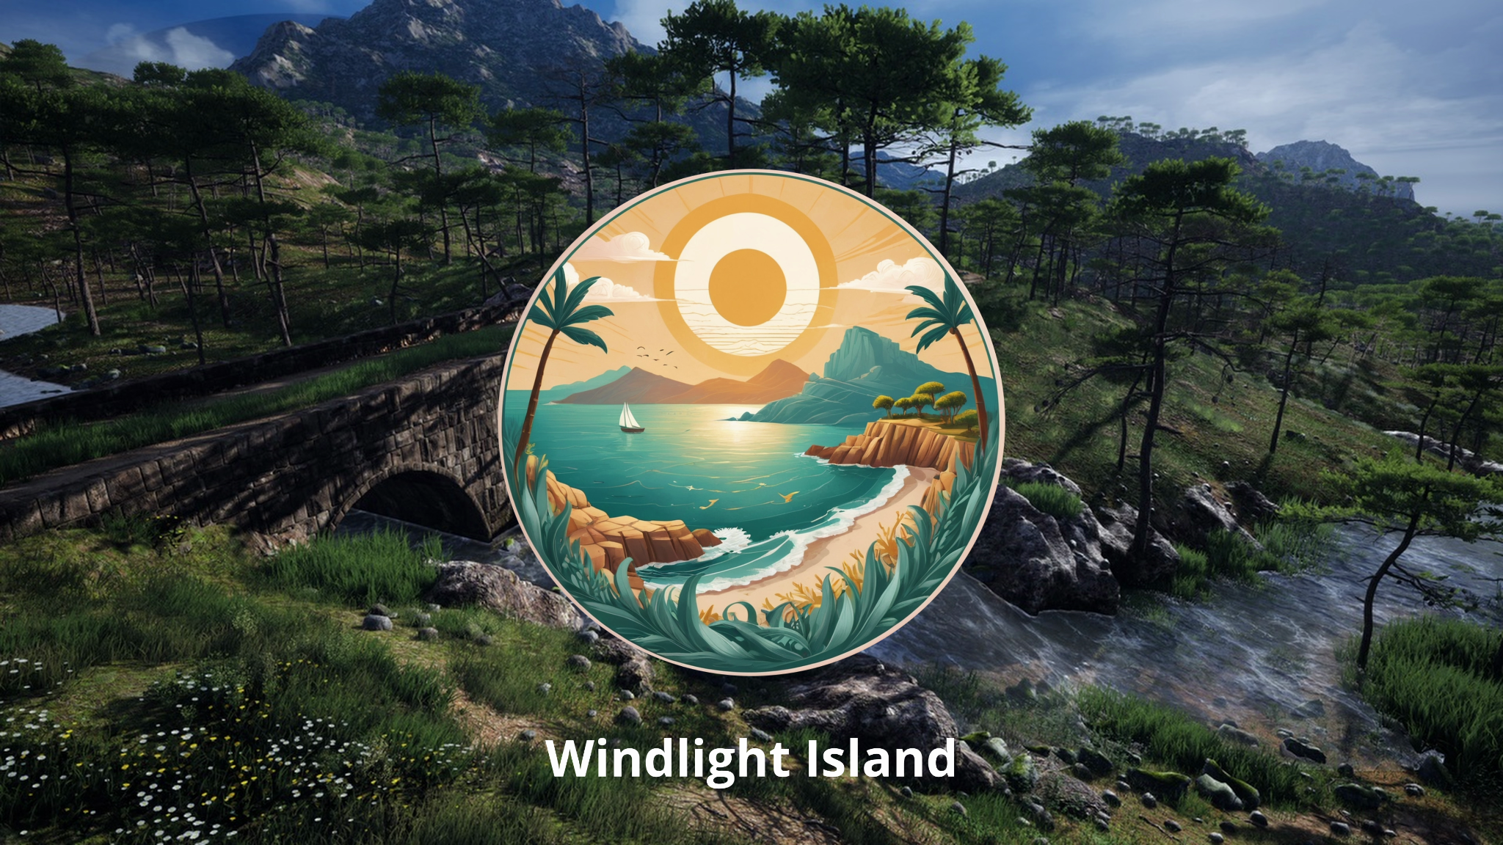

## What is in this guide?

| Link | Description |
| --- | --- |
| [Drive Link](https://drive.google.com/drive/folders/1GI-QEfHkHOdP4eDyhD31HLfFkmniKQuh?usp=sharing) | Download the playable build of **Windlight Island** from the Drive link. |
| [Webpage Windlight Island](https://sivatech24.github.io/windlightisland/) | Visit the official *Windlight Island* webpage for game details. |
| [Intro](https://youtu.be/RSEtcHDDhcg) | A cinematic introduction showcasing the tranquil world of Windlight Island. Highlights the natural beauty, mystery, and tone of the game. |
| [Gameplay](https://youtu.be/oiLJFeL1c1U) | Demonstrates key gameplay elements including exploration, lantern collection, wind puzzles, and the unlocking of the treasure cave. |